**IRRIGATION CONTROLLER**

**Version : 3**

**Date Updated : 5 - 5 - 2022**

**Overview :**

Irrigation Controller is used for greenhouse automation where it controls the growth of plants by controlling the water flowing to plants through pumps & valves.

Meanwhile it also sends data collected from the sensors based on user interest and sends it to the cloud via controller.

It works on three modes : Manual mode, Schedule Mode and Auto Mode. Where users can select any of these to control as per needs.

To connect to wifi for transfer of data collected it needs to connect to the controller via the input from Nextion device ( wifi page ).

**Recommended System Requirements :**

The Irrigation Controller works taking input from Nextion Device and Sends the data to Arduino mega wifi 2560 module and in some cases for wifi setup and to send data to cloud it needs in build esp - 8266 to connect to arduino.

The Irrigation controller coding is done through Arduino IDE in arduino module. The software is open source and can be installed from the Arduino website.

Website : <https://www.arduino.cc/>

The Nextion device consists of purely C language coding within the software provided by Nextion manufacturer. The file with nextion software supported extension is given below. The Software is open source and can be installed from the Nextion website.

Website : <https://nextion.tech/>

The UI of nextion device is designed using the Inkscape software. The file with the inkscape supported extension is given below. The Software is open source and can be installed from the Inkscape website.

Website : <https://inkscape.org/>

**Sample Code :**

There are two communication here :

1. From Nextion to Arduino : For this purpose The function

**func_name(){**

**func_name(){**

**………..**

**………..**

**………..**

**}**

1. From Arduino To Nextion : For this purpose the function

**func_name(){**

**func_name(){**

**………..**

**………..**

**………..**

**}**

**How to use the Software :**

The basic things required for this software to use are:

1. UI design
2. Pure C Language Coding

Below I’m sharing the Youtube Channel from where one can easily understand the project.

Everything in the project has taken reference from the videos of this channel only.

Reference : <https://www.youtube.com/c/CheapControls>

**Summary of Project :**

This project consists of a total of 48 pages of Nextion.

Welcome page

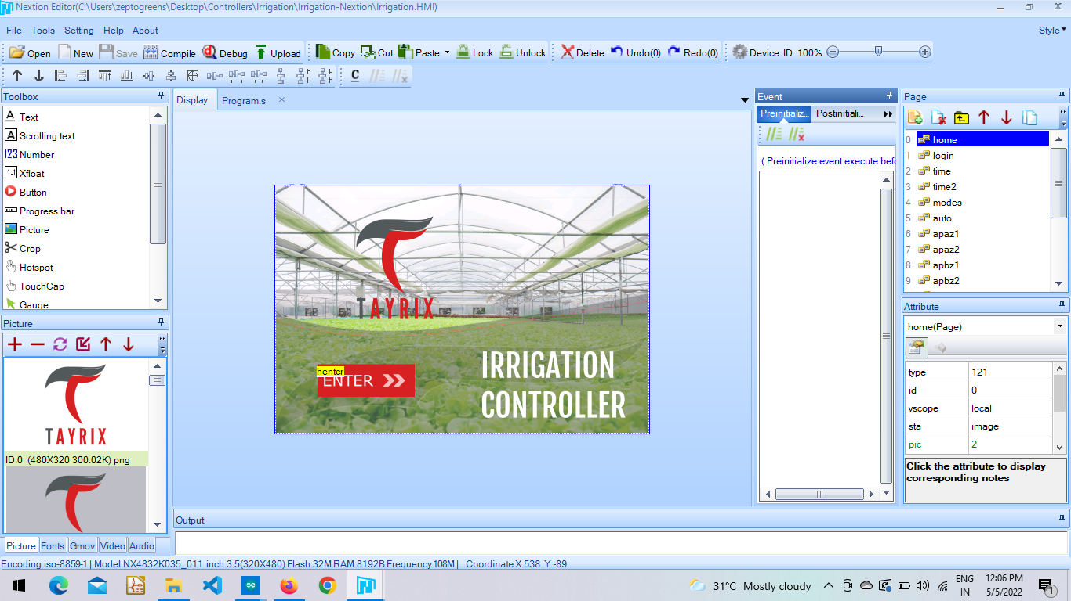

Login Page.

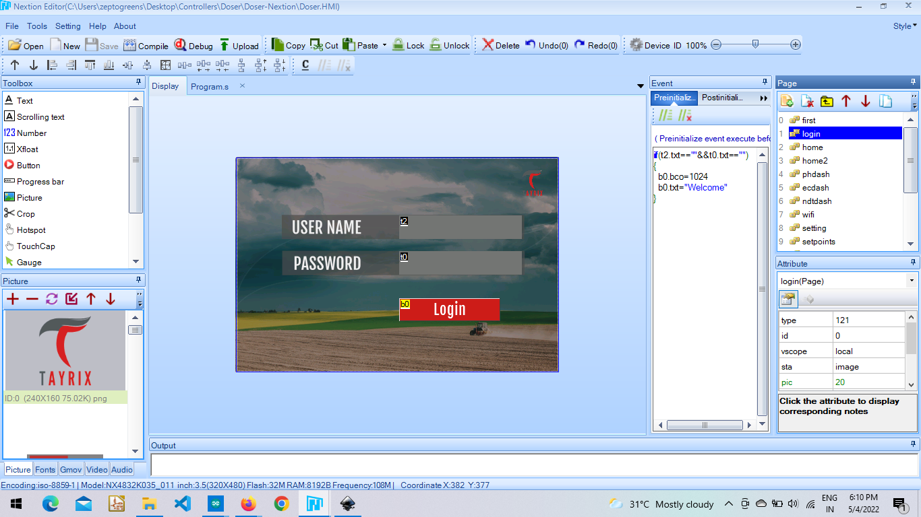

**Home Page :** Consists of two paes one for Zone 1 and Zone 2.

The input shows from sensors such as : solar radiation sensor, water level sensor, water flow sensor for Zone 1. And navigation buttons for respective modes like: Auto mode, Schedule and Manual mode.

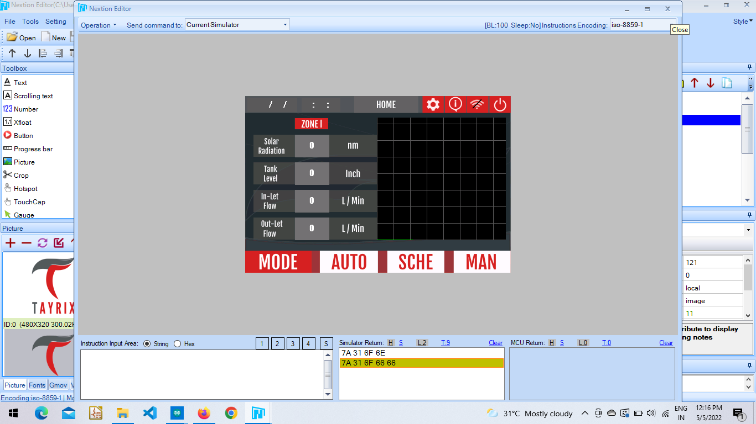

The input shows from sensors such as : solar radiation sensor, water level sensor, water flow sensor for Zone 2. And navigation buttons for respective modes like: Auto mode, Schedule and Manual mode.

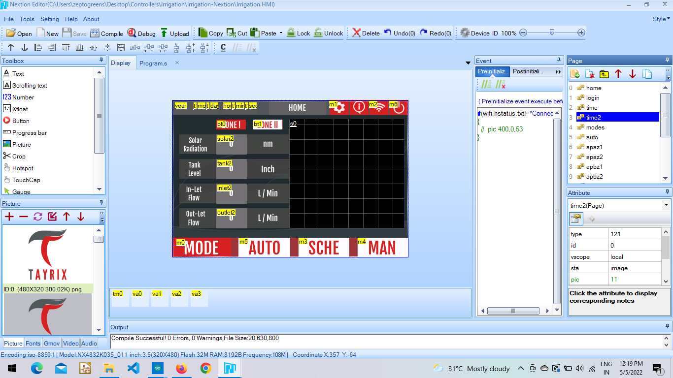

***v*func_name(){**

**func_name(){**

**………..**

**………..**

**………..**

**}**

**Auto Mode Page :** It consists of three Pumps each for two Zones.

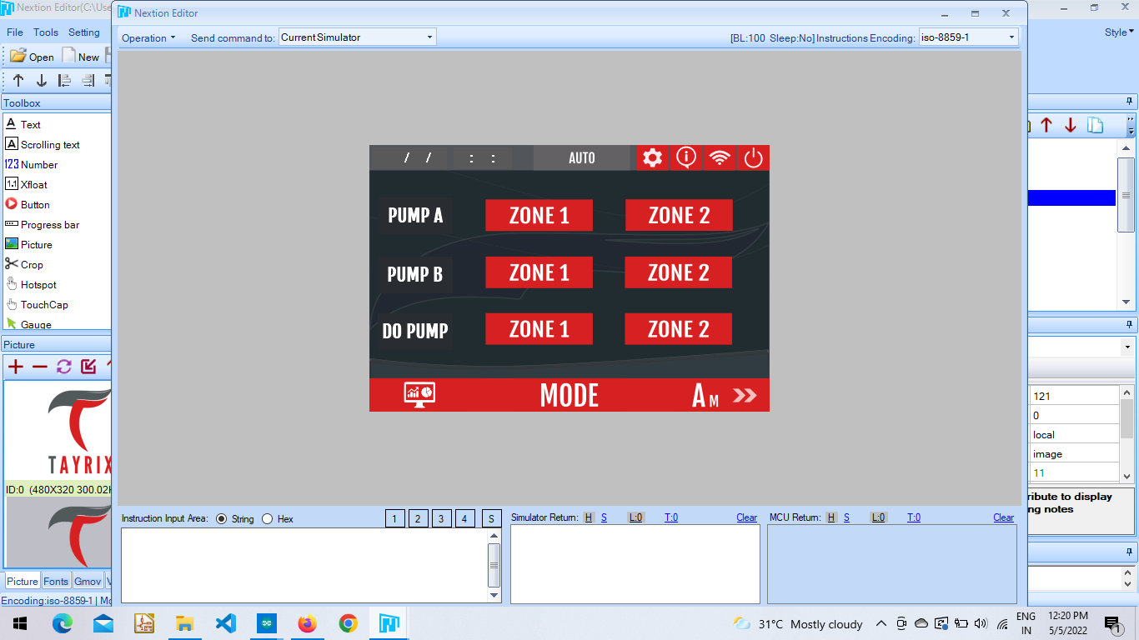

**Pump A - Zone1 :** The user needs to enter the onTime and OffTime timings to run the Pump A of Zone1. OnTime here is on the pump and OffTime to keep the pump off. The save button consists of code, when user save and click on toggle button to ON/OFF the pump the signal is sent to the arduino from where the relays work which then connects to the pump.

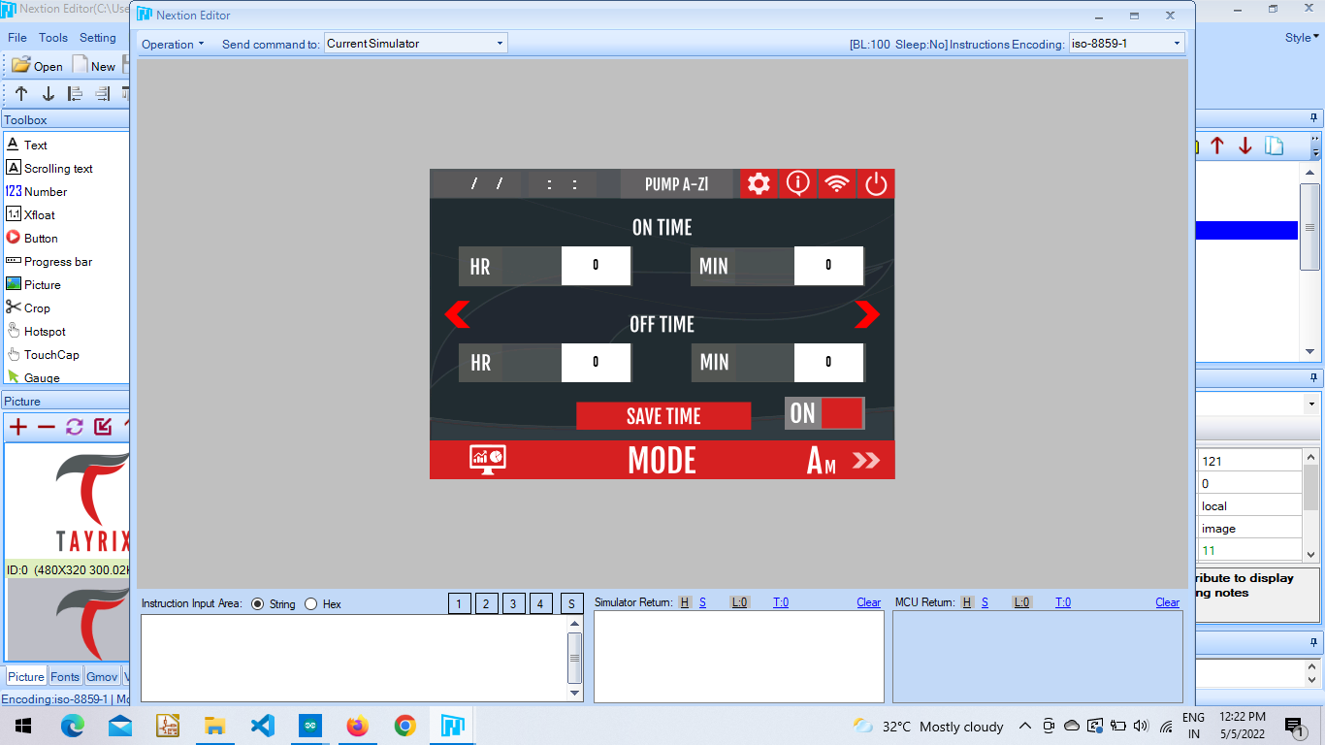

**Pump A - Zone2 :** The user needs to enter the onTime and OffTime timings to run the Pump A of Zone2. OnTime here is on the pump and OffTime to keep the pump off. The save button consists of code, when user save and click on toggle button to ON/OFF the pump the signal is sent to the arduino from where the relays work which then connects to the pump.

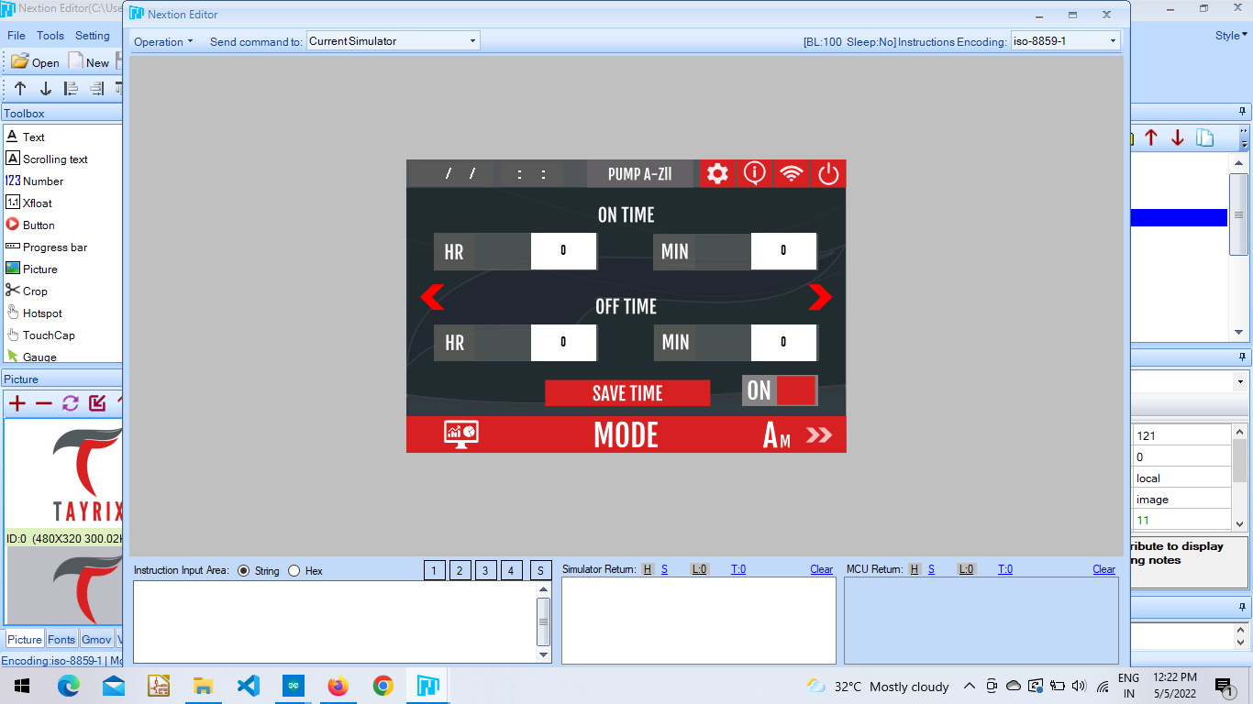

**Pump B - Zone1 :** The user needs to enter the onTime and OffTime timings to run the Pump B Zone1. OnTime here is on the pump and OffTime to keep the pump off. The save button consists of code, when user save and click on toggle button to ON/OFF the pump the signal is sent to the arduino from where the relays work which then connects to the pump.

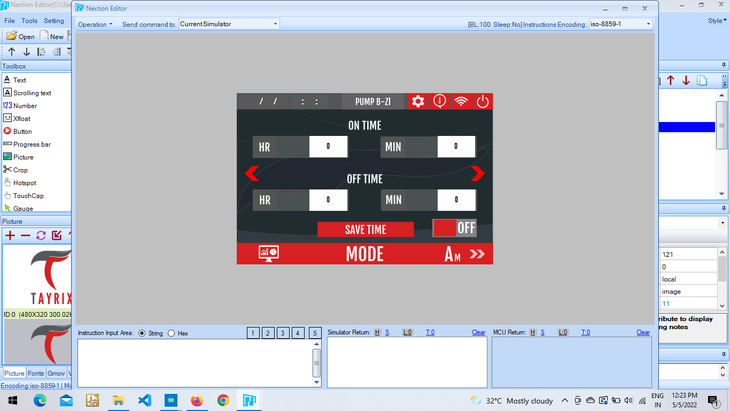

**Pump B - Zone2 :** The user needs to enter the onTime and OffTime timings to run the Pump B of Zone2. OnTime here is on the pump and OffTime to keep the pump off. The save button consists of code, when user save and click on toggle button to ON/OFF the pump the signal is sent to the arduino from where the relays work which then connects to the pump.

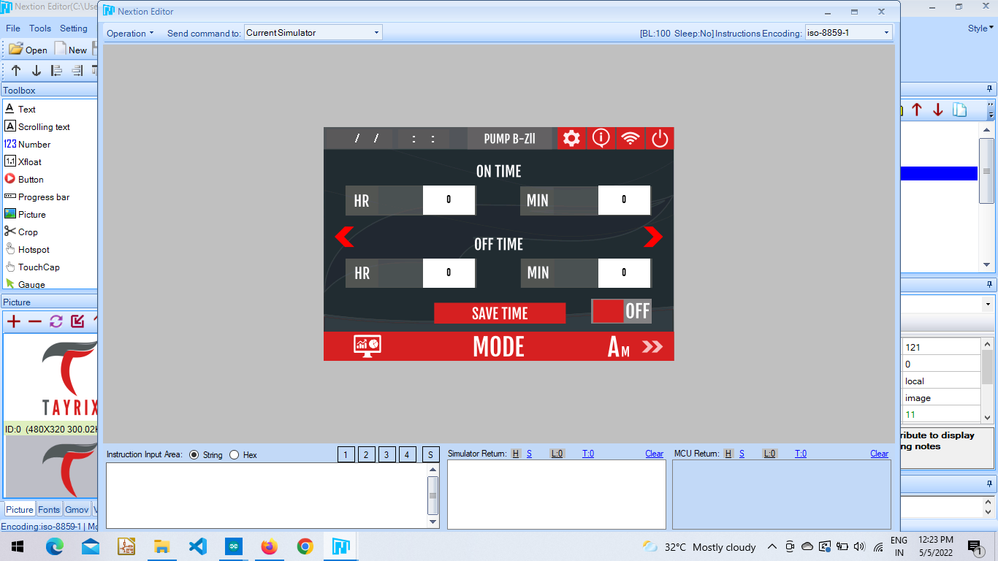

**Pump DO - Zone1 :** The user needs to enter the onTime and OffTime timings to run the Pump DO of Zone1. OnTime here is on the pump and OffTime to keep the pump off. The save button consists of code, when user save and click on toggle button to ON/OFF the pump the signal is sent to the arduino from where the relays work which then connects to the pump.

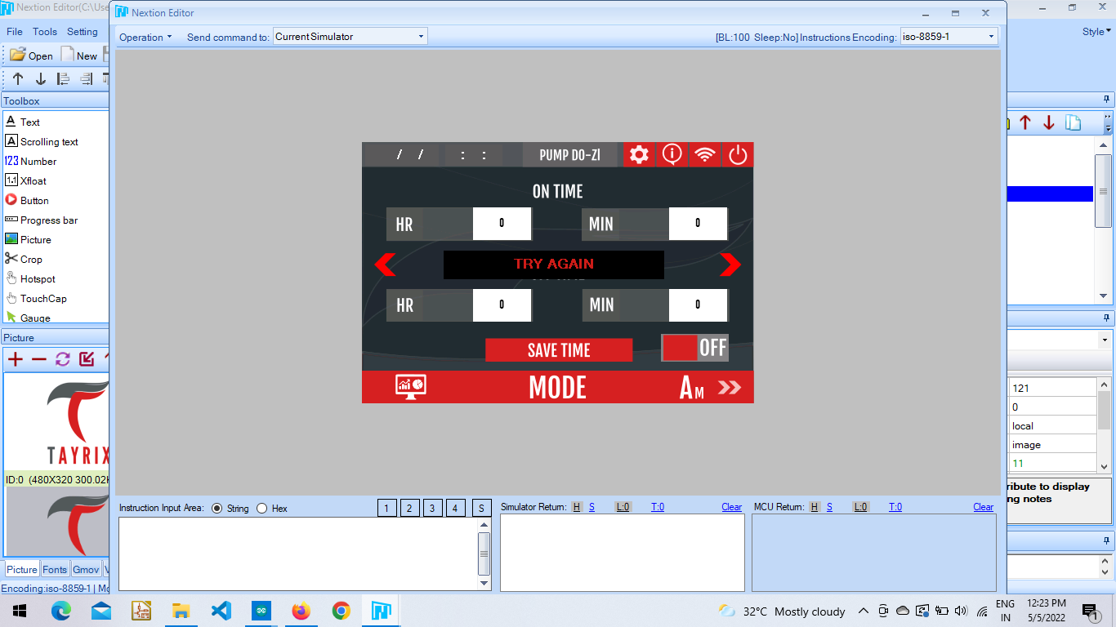

**Pump DO - Zone2 :** The user needs to enter the onTime and OffTime timings to run the Pump DO of Zone2. OnTime here is on the pump and OffTime to keep the pump off. The save button consists of code, when user save and click on toggle button to ON/OFF the pump the signal is sent to the arduino from where the relays work which then connects to the pump.

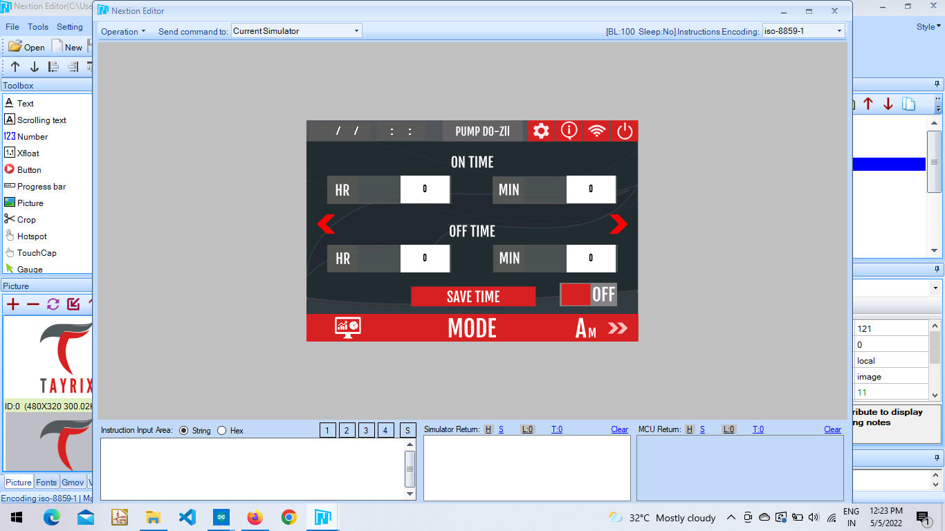

**func_name(){**

**func_name(){**

**………..**

**………..**

**………..**

**}**

**Schedule Mode Page :** It consists of three Pumps each for two Zones. Each Zone here consists of 8 - slots which are divided into 4-pages, 2 slots for each page.

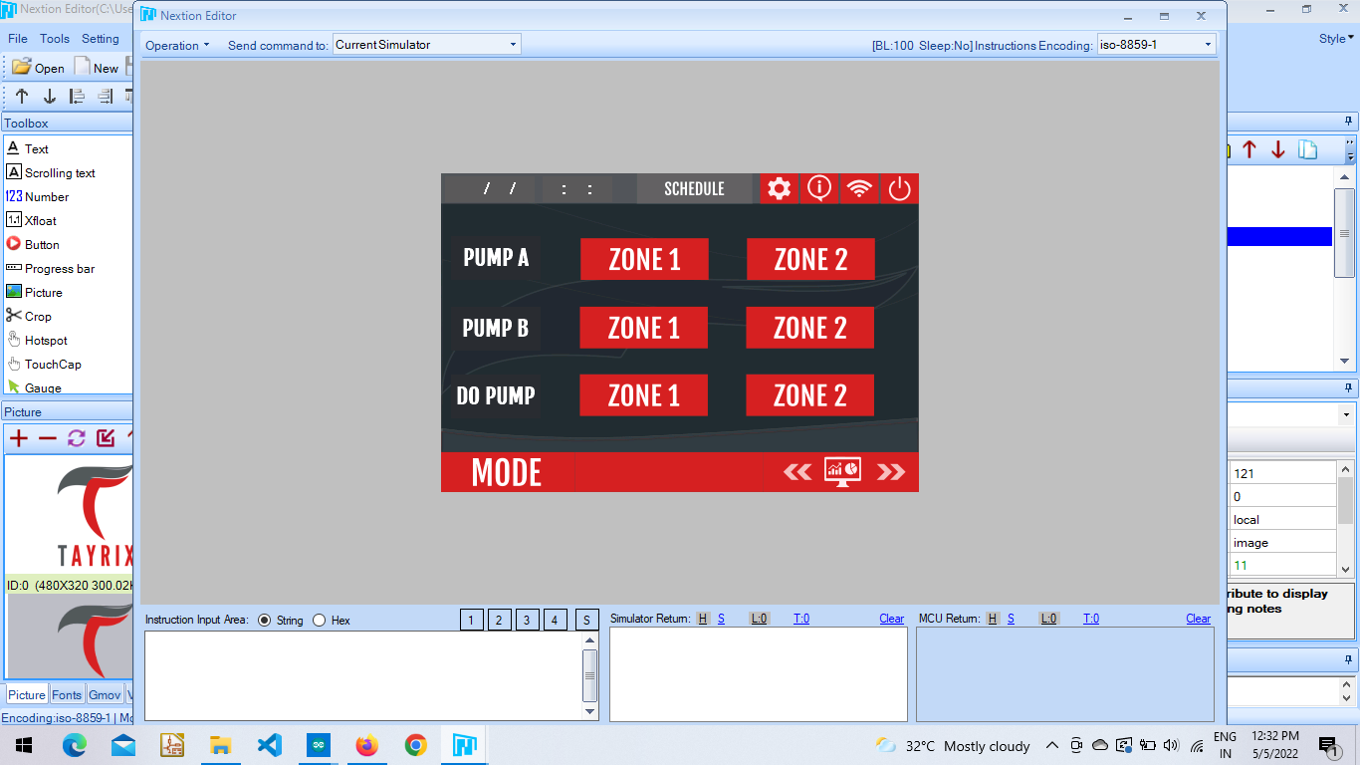

**Pump A - Zone1 :** The user needs to enter the onTime and OffTime timings for each slot to run the Pump A of Zone1. OnTime here is on the pump and OffTime to keep the pump off.

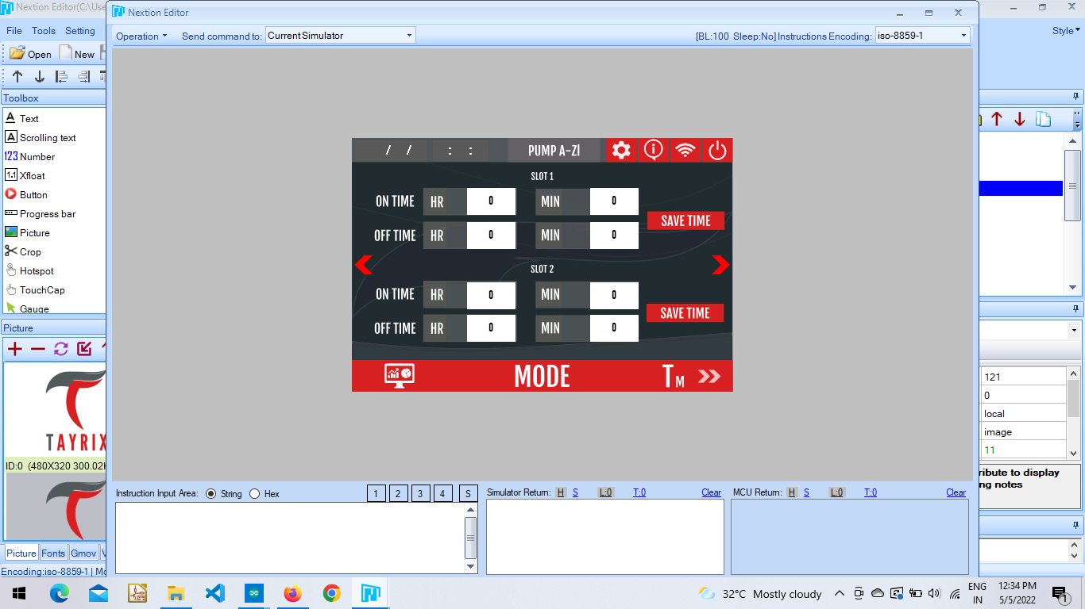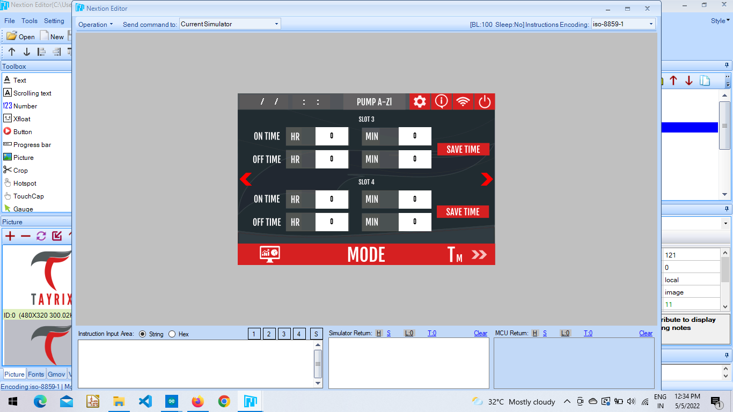

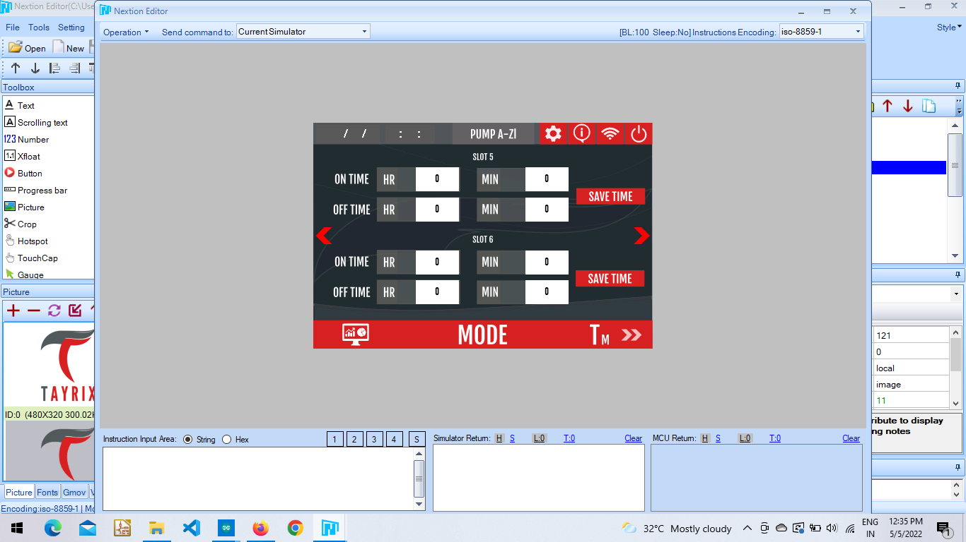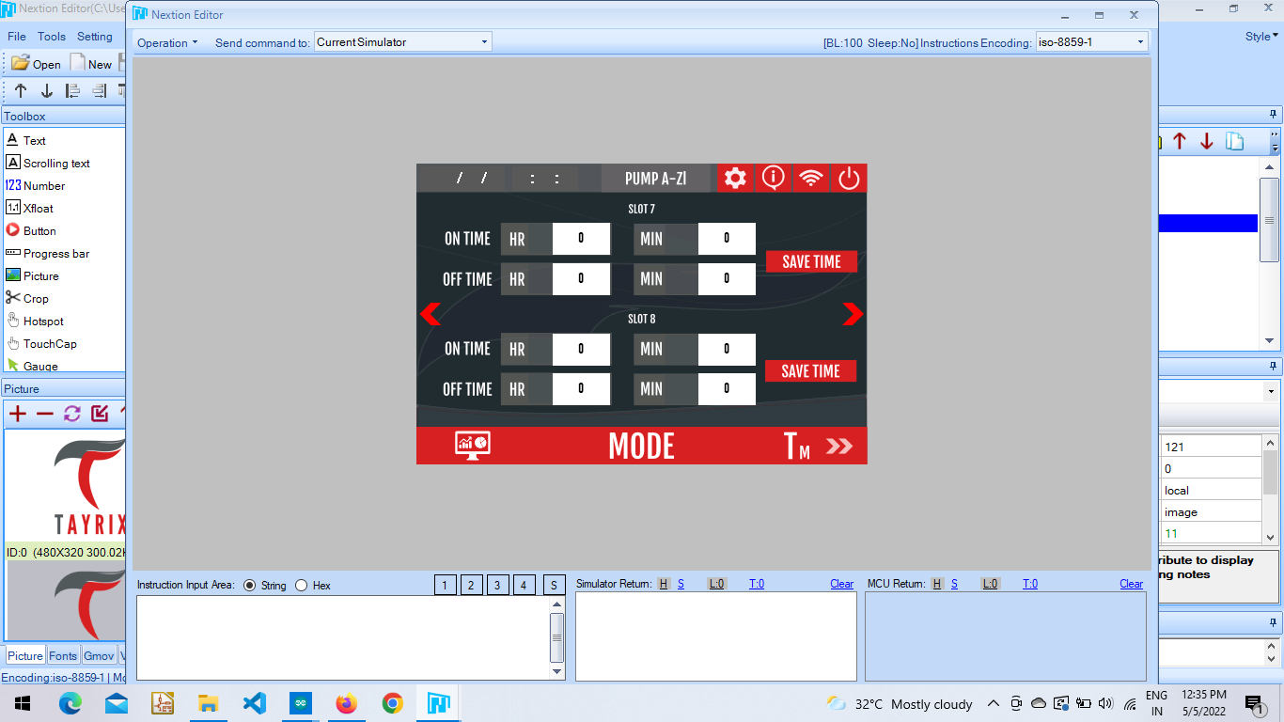

**Pump A - Zone2 :** The user needs to enter the onTime and OffTime timings for each slot to run the Pump A of Zone2. OnTime here is on the pump and OffTime to keep the pump off.





**Pump B - Zone1 :** The user needs to enter the onTime and OffTime timings for each slot to run the Pump B of Zone1. OnTime here is on the pump and OffTime to keep the pump off.





**Pump B - Zone2 :** The user needs to enter the onTime and OffTime timings for each slot to run the Pump B of Zone2. OnTime here is on the pump and OffTime to keep the pump off.





**Pump DO - Zone1 :** The user needs to enter the onTime and OffTime timings for each slot to run the Pump DO of Zone1. OnTime here is on the pump and OffTime to keep the pump off.





**Pump DO- Zone2 :** The user needs to enter the onTime and OffTime timings for each slot to run the Pump DO of Zone2. OnTime here is on the pump and OffTime to keep the pump off.





**func_name(){**

**func_name(){**

**………..**

**………..**

**………..**

**}**

**Manual Mode :** In this mode users can manually control the pumps for each zone.

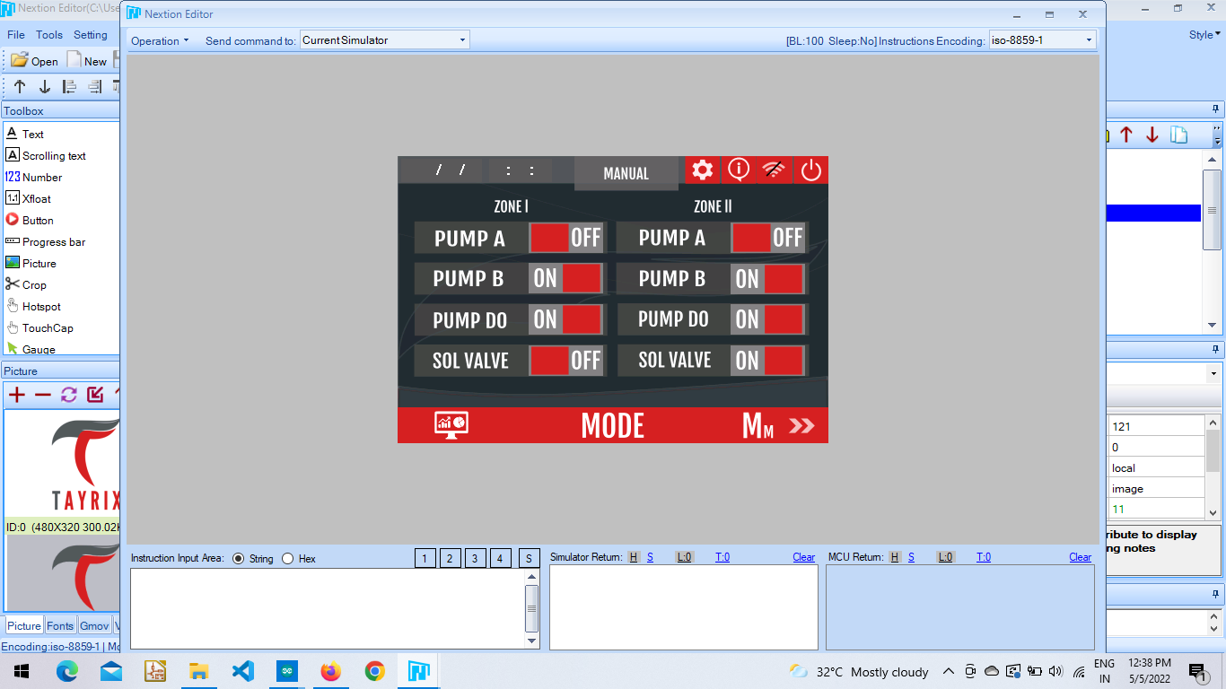**.**

**func_name(){**

**func_name(){**

**………..**

**………..**

**………..**

**}**

**Settings Page :** This page consists of the different options.

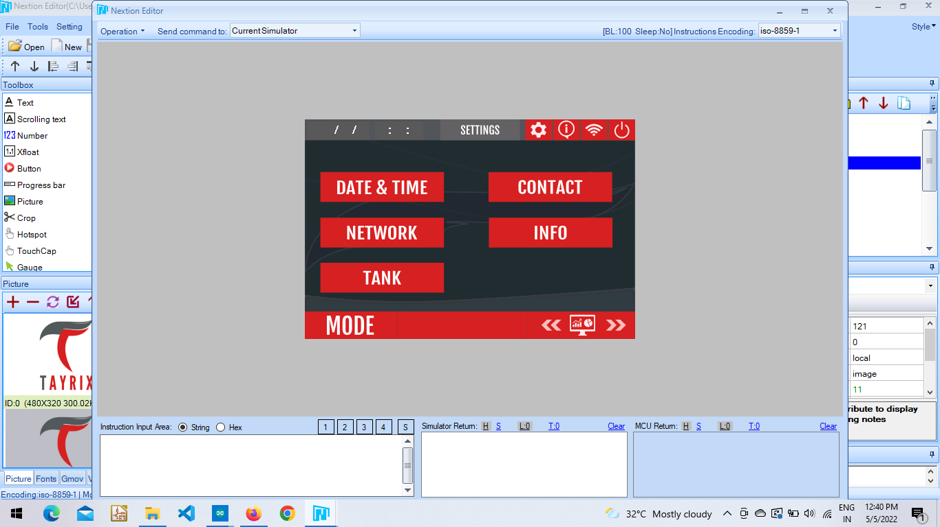

**Date & Time :** This page is used to set the time on nextion device. Here we need to first set the current time and then save it. When the save button is clicked the values are sent to the arduino and when the set button is clicked the arduino sends back the selected time after updating its RTC. Thus both Arduino Rtc and Nextion Rtc will be running at the same time.

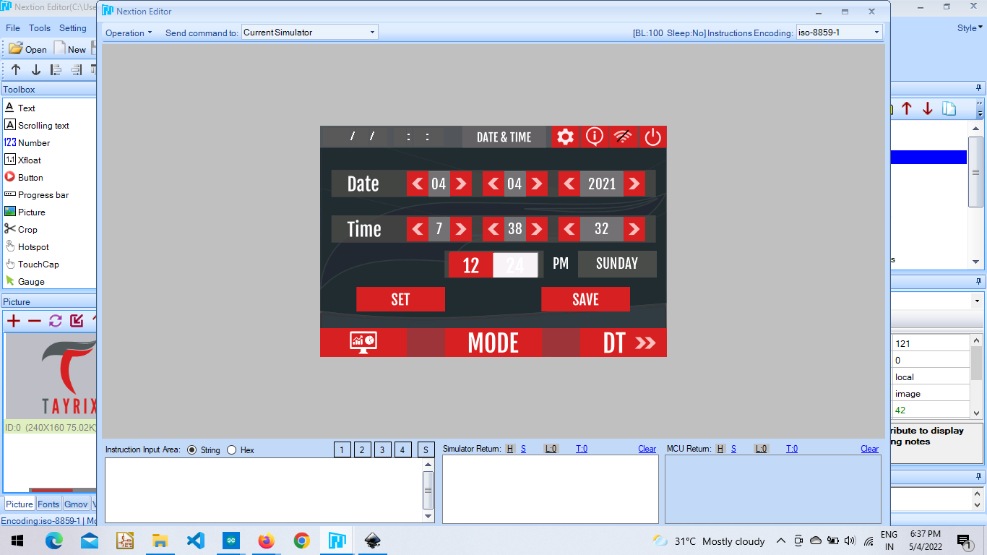

**func_name(){**

**func_name(){**

**………..**

**………..**

**………..**

**}**

**Info :** The chip id and flash id is shown from arduino mega after receiving from esp 8266.

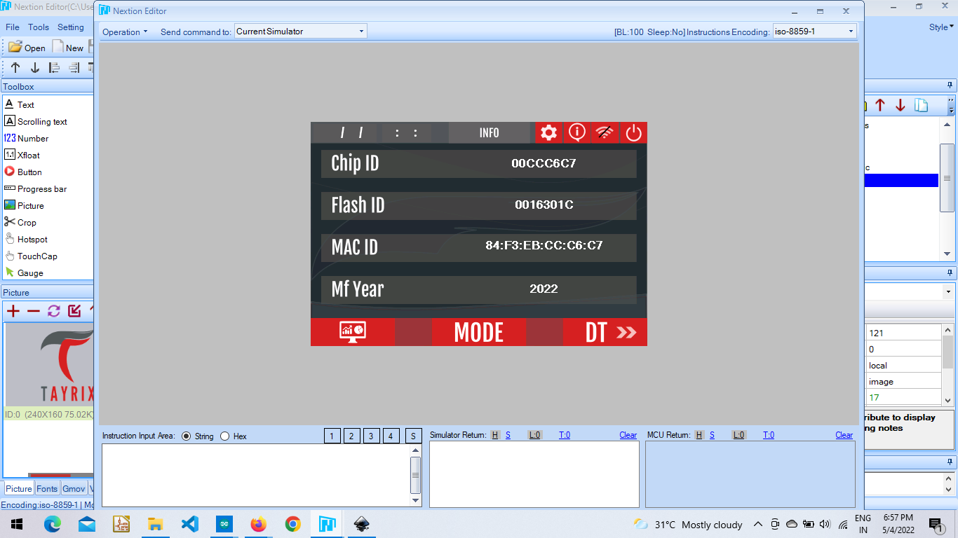

**Network :** This page consists of wifi configuration, cloud and mess configuration.

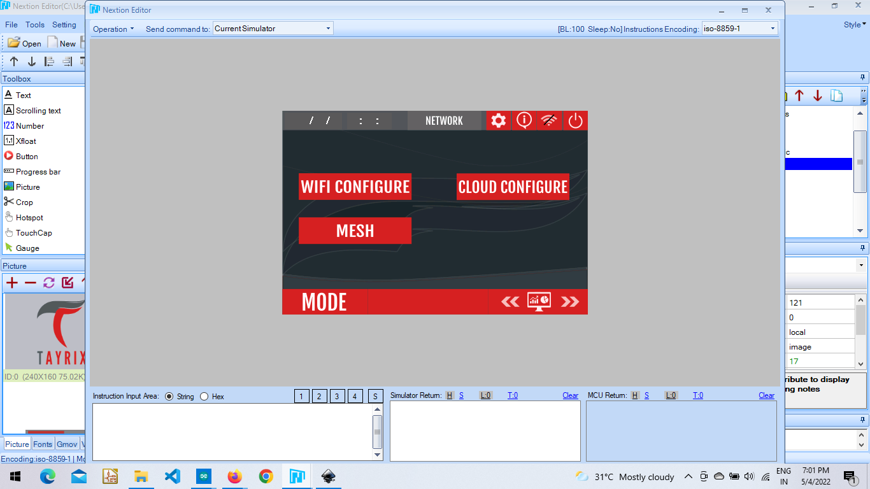

**Wifi Configuration :** User needs to enter the SSID and Password in order to connect to wifi so that the esp 8266 can start working to send data collected from sensors and relays to the cloud. The box “status” takes the signal from esp 8266 whether the wifi is connected or/not and sends the signal to arduino mega from where it is shown here.

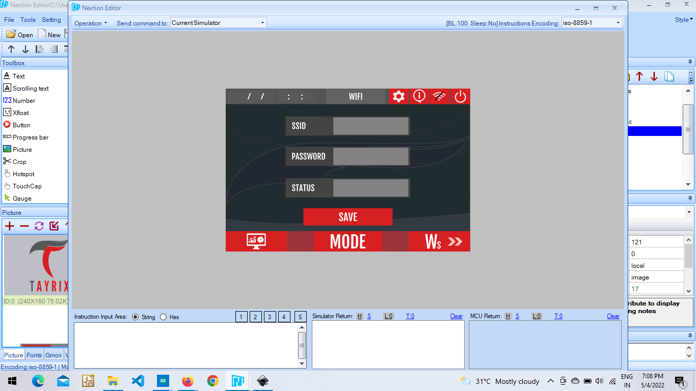

**func_name(){**

**func_name(){**

**………..**

**………..**

**………..**

**}**

**Cloud Configuration :** This page is to enter credentials to connect to the cloud.

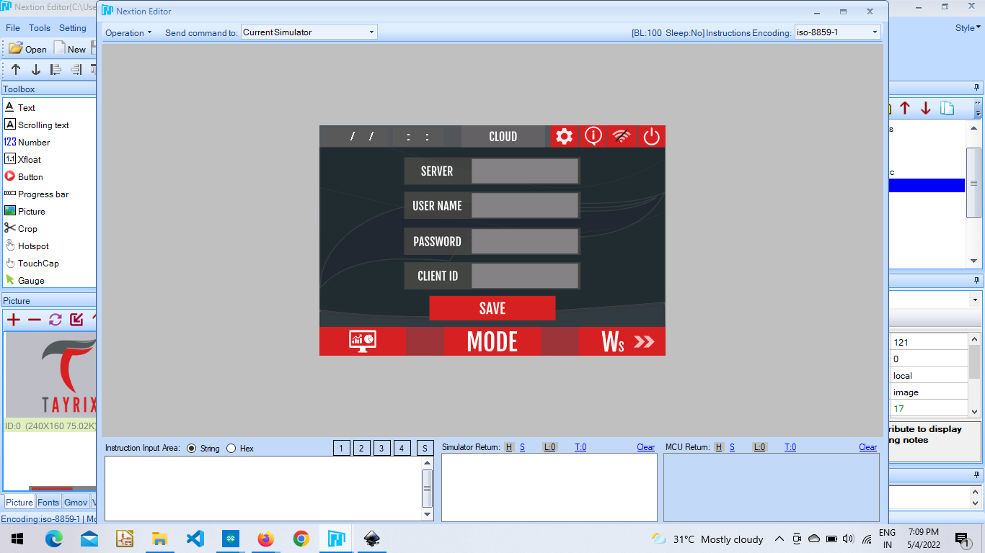

**func_name(){**

**func_name(){**

**………..**

**………..**

**………..**

**}**

**Mesh Configuration :** This page is designed to connect the Master node.

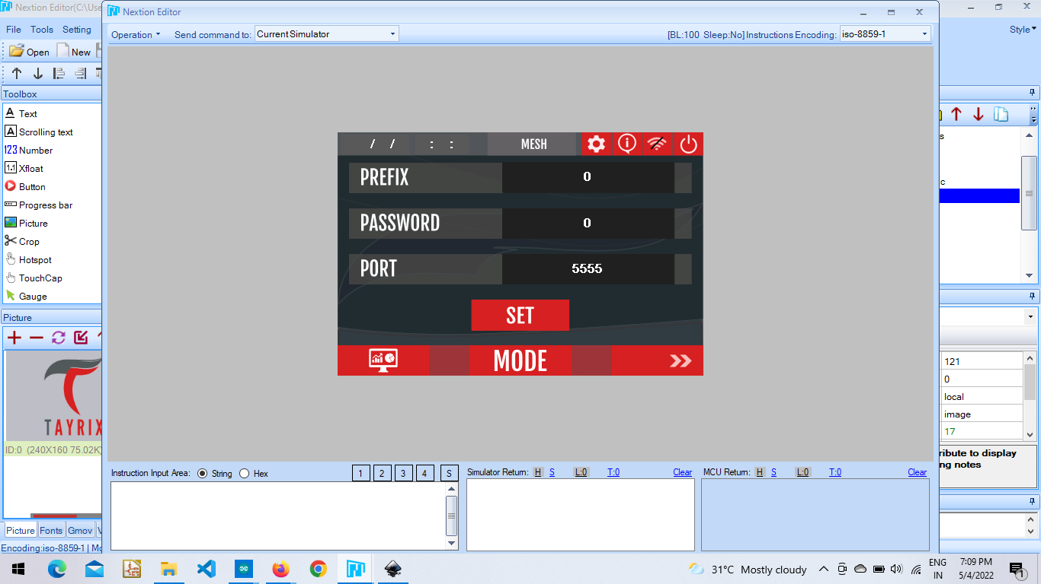

**func_name(){**

**func_name(){**

**………..**

**………..**

**………..**

**}**

**Tank Settings :** This page is used to control the water level inside the tank depending on the requirement. The user needs to give how much is the height of the tank and the requirement needed i.e. level of tank in inches in “Set Level Box”. The calculation after receiving values from the sensor is done within arduino mega and displayed in the “Tank Level Box”. Users need to save the values of height and set level then select the ON/OFF toggle button, to run the tank management system. If the tank level is less than the set level then the RO Pump is on flipping up the tank depending on requirement.

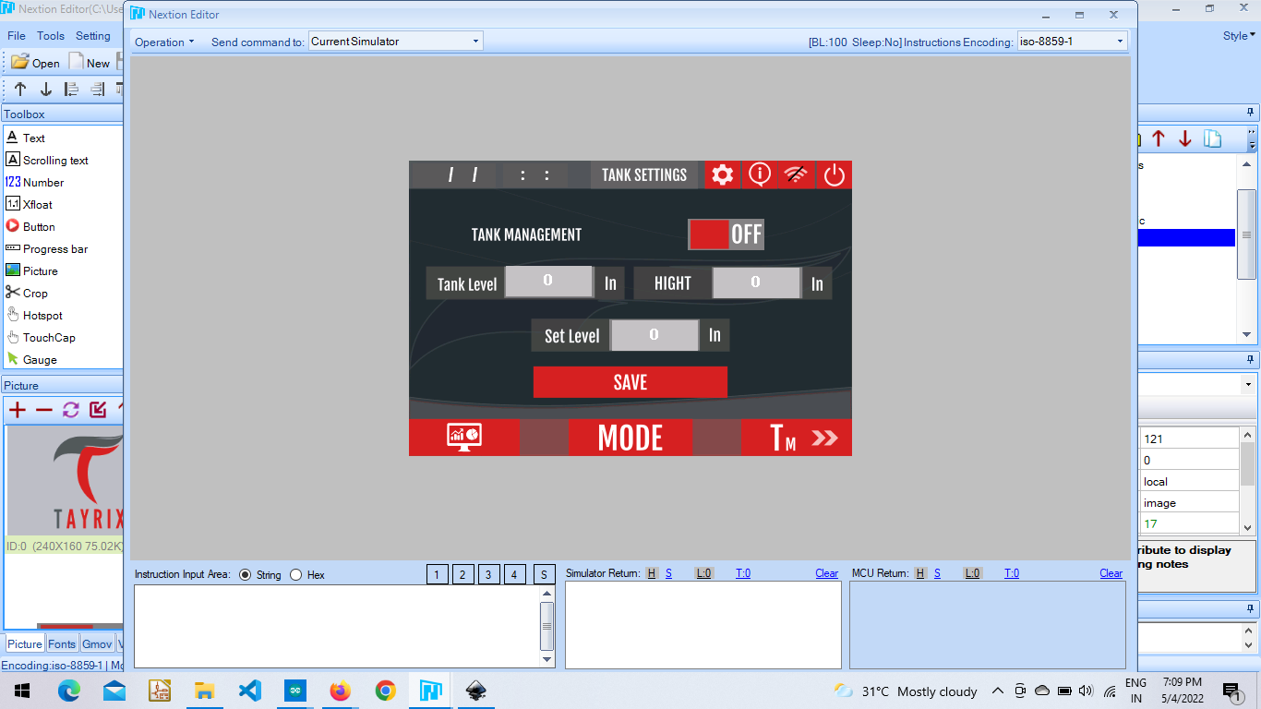

**func_name(){**

**func_name(){**

**………..**

**………..**

**………..**

**}**

**Credits :** This project has been undertaken by Mr. Raj Kumar. Ardunio Mega and Esp 8266 coding was done by Him Only. Under his guidance I have worked on Nextion to Arduino and vice versa communication.

**Contact Information :**

Feel free to contact the address below for further help.

E-mail Id **:** [**01zeptohas@gmail.com**](mailto:01zeptohas@gmail.com)